1. Start SQL Profiler by one of the following ways:
- Click Start\All Programs\Microsoft SQL Server XXX\ Performance Tools and choose SQL Server Profiler
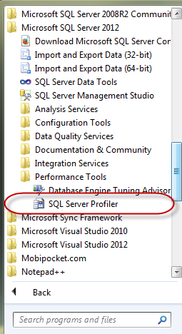
- From SSMS choose Tools \ SQL Server Profiler
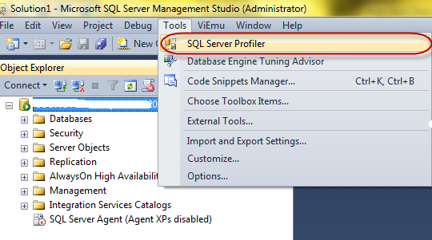

2. Events Selection
- In the Event Selection tabl of Trace Properties dialog, choose Events that will be captured as Stored Procedures, TSQL...
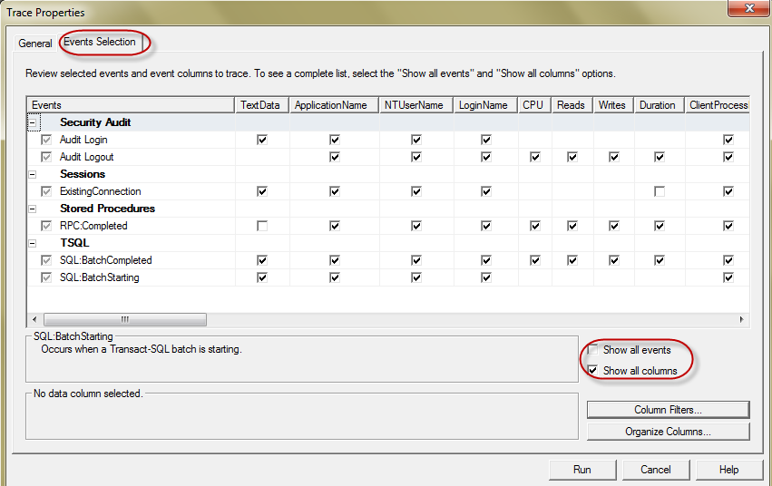
- Specific Database which Profiler will trace. Click Column Filters... button, select DatabaseName and enter AdventureWorks into Like
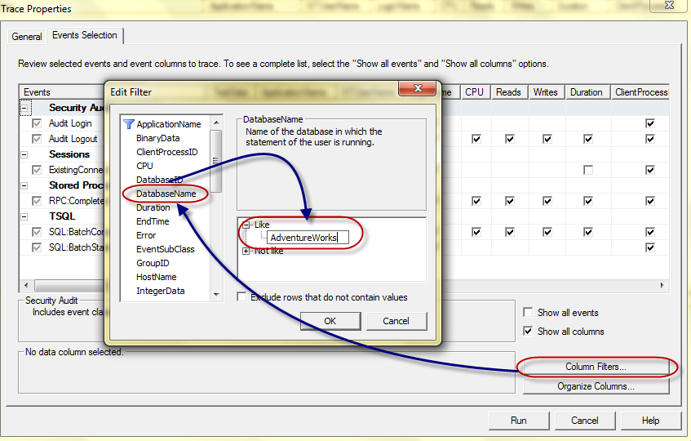

3. Capturing T-SQL events

- In SSMS types:

SELECT * FROM [HumanResources].[Employee]
and run (F5) under AdventureWorks database
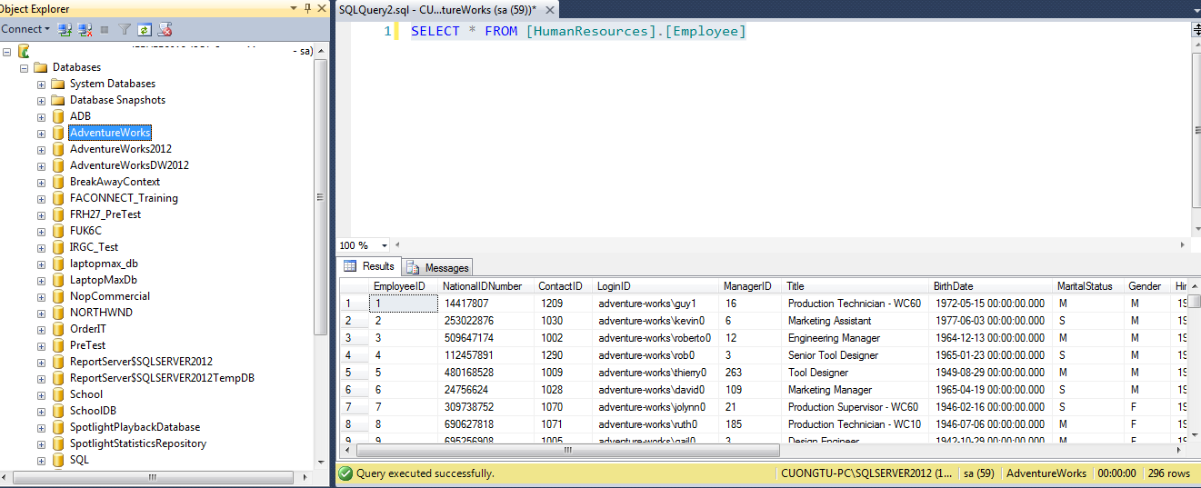
- Go back SQL Server Profiler, it shows:
- T-SQL statement in the TextData column
- The time that query takes in Duration column (173 ms)
- I/O information in Reads, Writes column
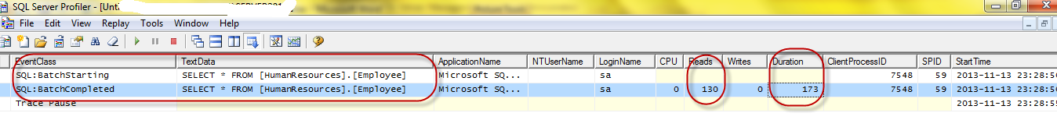

4. Capturing Stored Proc events

Copy and Execute below statement
USE AventureWorks
GO
EXEC dbo.uspGetManagerEmployees 16

